2019 T-20
T-20 Messenger Bowl Division 1 T-20 Final Results
Grand Final
Pembroke v Adelaide High School
Hi all,
Congratulations to Pembroke and Adelaide High School on reaching the Division 1 Messenger Bowl T-20 Grand Final.
This final was originally scheduled to be played this Wednesday at Adelaide University Oval but due to the predicted heat the game has been postponed to Friday 22/11 to be played at Kensington Oval.

Scotch won the SAAS Division 2 Title by percentage, in a closely contested competition.
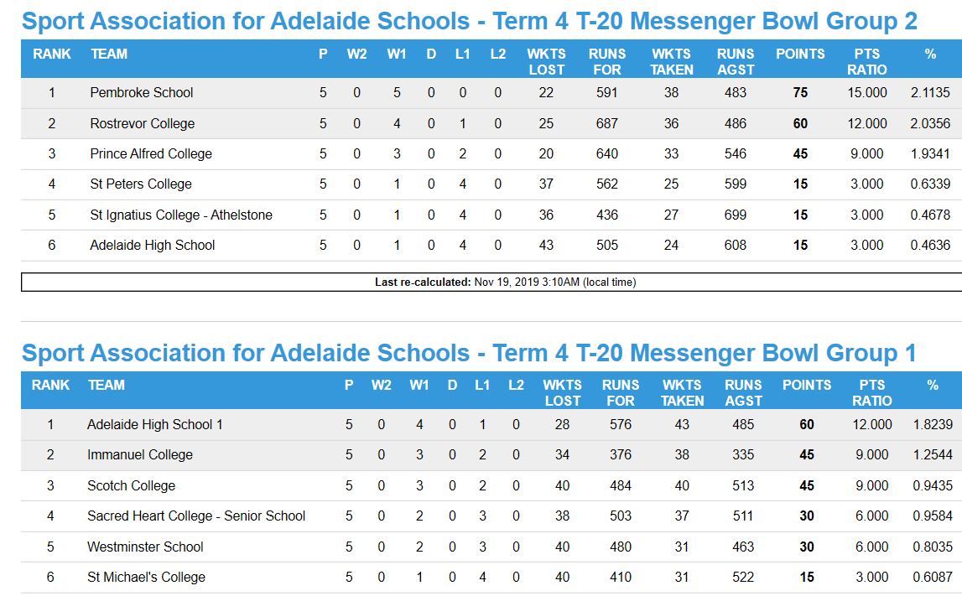

T-20 SAAS Division 2 T-20 Final Results
