Walkervile Oval
Smith Street, Walkerville
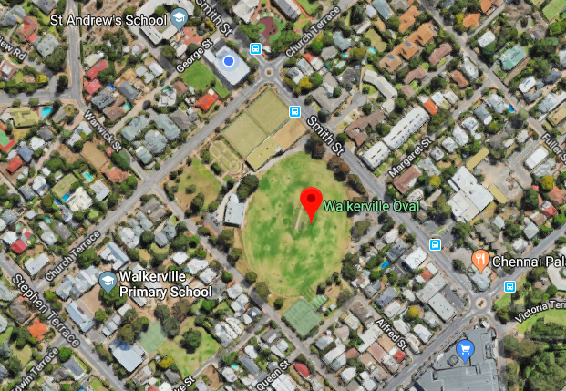
Levi Caravan Park
Corner of Vale Street & Lansdowne Terrace, Vale Park
