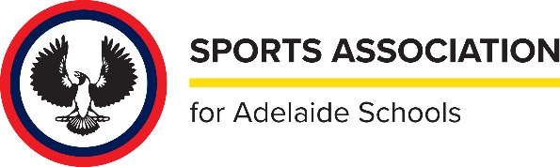
SAAS UMPIRE PANEL
OFFICIALS

Current as of February 2023

YEAR COORDINATOR COACHES
2022 ADNON JAFARI COLIN STEINERT AKRAM RASHEED
2021 JASON BROWN COLIN STEINERT AKRAM RASHEED ADNON JAFARI
2020 COLIN STEINERT/JASON BROWN AKRAM RASHEED JASON BROWN
2019 COLIN STEINERT AKRAM RASHEED JASON BROWN
2018 COLIN STEINERT AKRAM RASHEED JACK LESKE
2017 COLIN STEINERT AKRAM RASHEED JACK LESKE
2016 COLIN STEINERT AKRAM RASHEED JACK LESK
2015 COLIN STEINERT AKRAM RASHEED JACK LESKE
2014 COLIN STEINERT ROB MURPHY
2013 COLIN STEINERT ROB MURPHY
2012 COLIN STEINERT ROB MURPHY
2011 COLIN STEINERT ROB MURPHY
2010 COLIN STEINERT ROB MURPHY
2009 COLIN STEINERT ROB MURPHY
2008 COLIN STEINERT ROB MURPHY
2007 COLIN STEINERT ROB MURPHY
2006 COLIN STEINERT ROB MURPHY
2005 COLIN STEINERT ROB MURPHY
2004 COLIN STEINERT ROB MUJRPHY
2003 COLIN STEINERT ROB MURPHY
2002 COLIN STEINERT ROB MURPHY
2001 COLIN STEINERT ROB MURPHY
2000 COLIN STEINERT ROB MURPHY
1999 TONY MIRANDA TONY MIRANDA
1998 TONY MIRANDA TONY MIRANDA
1197 TONY MIRANDA TONY MIRANDA

