School Courts
Church Terrace, Walkerville
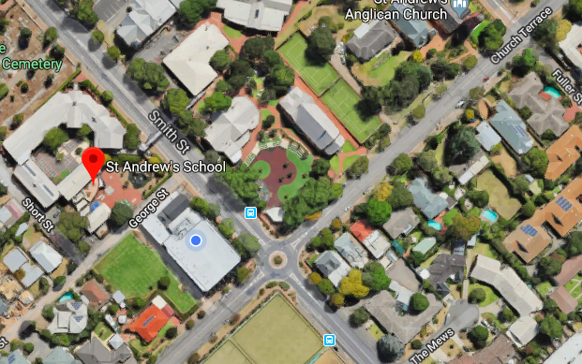

Walkerville Lawn Tennis Club
Corner of Creswell Court and Stephen Terrace, Gilberton

