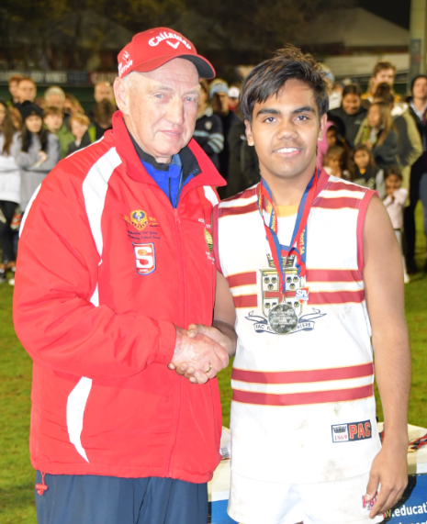
COLIN STEINERT Biography
The Best on Ground Medal in the State Knockout Cup is named after
Colin Steinert. Colin has a long involvement in Senior Football as a
SANFL League Field Umpire and a wide range of School Boys
Football roles.
The medal was first named after Colin in 1988 in recognition of
all his contributions in helping the game grow.
Many players who have won this prestigious medal have gone onto
play the game at the highest level.
PLAYER
Ten years as a player with Adelaide Teachers College, Renmark,
West Gambier and Gawler Centrals.
TEACHER
From 1962-1979 was a Physical Education Teacher, Senior Master and Sports Coordinator at Renmark, Mt Gambier, Elizabeth, Modbury, and Gilles Plains High Schools.
COACH
Community Football - 1966-1968 Coached West Gambier U18’s
School Football - 1966-1968 coached SAPSASA country teams
1969-1979 coached under age and lst XVIII school teams-
Involved with the development of over 40 League and AFL players
ADMINISTRATOR
SASSSA – Secondary School Sport
1979-1989 Executive Officer – established the Secondary Schools State Wide Knock Out Football Program with Murray Tippett (SANFL) and Tom Tomlinson (Pizza Hut)
U15 School Sport National Championship
1975 Umpires Convenor
1982-86 Championship Convenor – 3 Championships
1988 SASSSA Executive first awarded “The Colin Steinert Medal” for the Best on Ground in the State Wide Knockout Grand Final
1994 Chairman of Organising Committee U15 National Football Championship
2012 Convenor of Australian Team Selectors for U15 National Championship
SCHOOL SPORT AUSTRALIA
Ten Years as Executive and Board Member.
SANFL
1979-1989 Chairman SANFL Schools Football Committee
1979-1989 Schools Representative on the SANFL Game Development Council
Compiled and established the SANFL Schools Football Charter
FIELD UMPIRE
SANFL 8 years and over 140 League and Seconds Games
ISSA 4 yrs at lst XVIII level
SANFL 6 years at A1 and A2 level
School Sport Australia – 7 years at National U15 Championships.
LIFE MEMBERSHIPS
1986 School Sport Australia Football Committee
1987 School Sport Australia
1988 SASSSA
2002 Sport SA
Foundation Member of SANFL

