Instructions to Create a Registration Form
This will enable players to be allocated to Teams (and for eScoring player stats).
- Select View
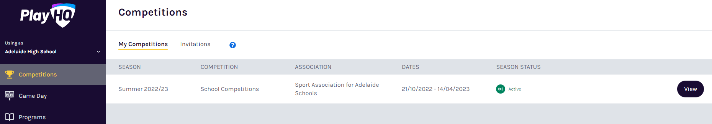

- Select Registrations
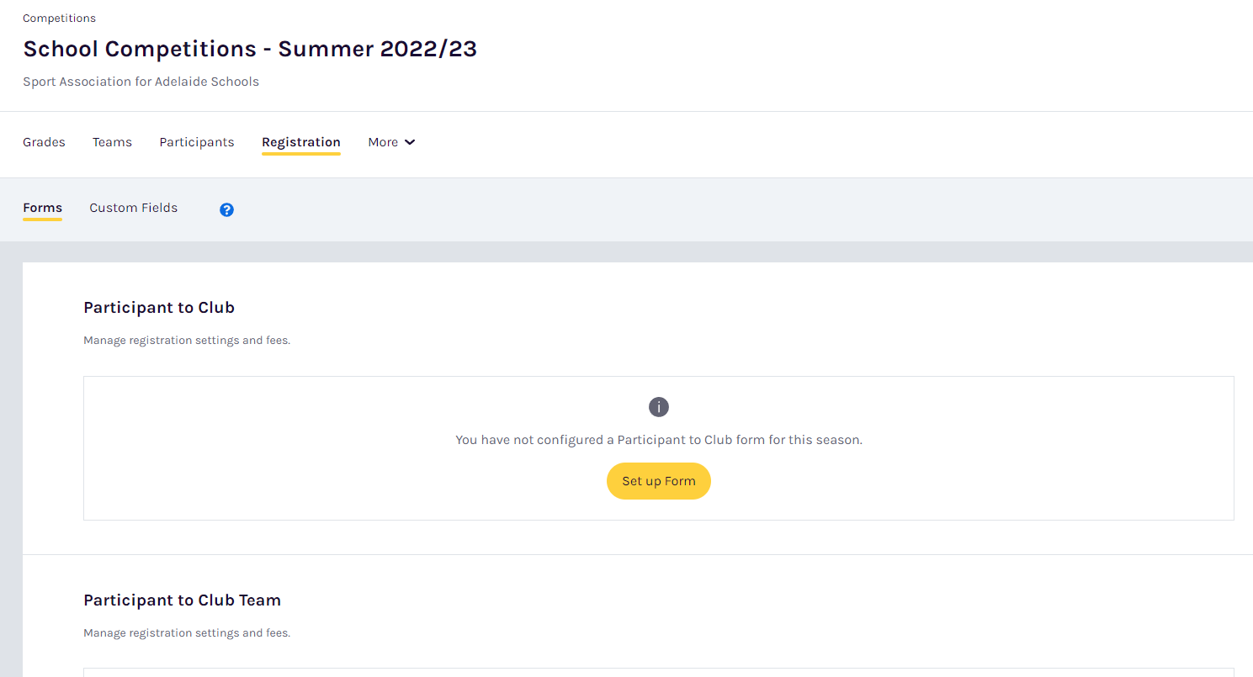
- Enter Date range as per below.
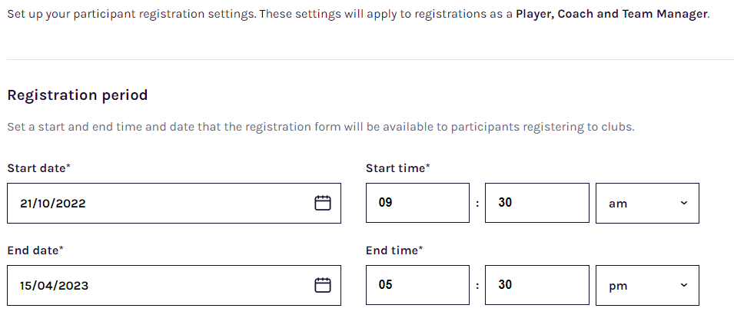

- Set a registration fee of 0.00.
This amount must be manually entered into the form which overrides the grey recommended amount of 0.00.
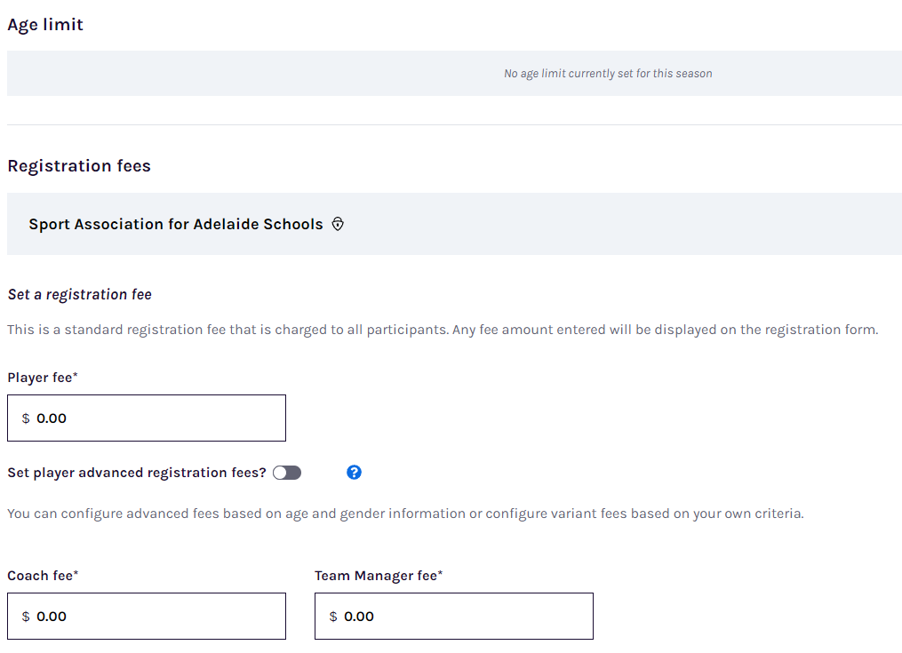
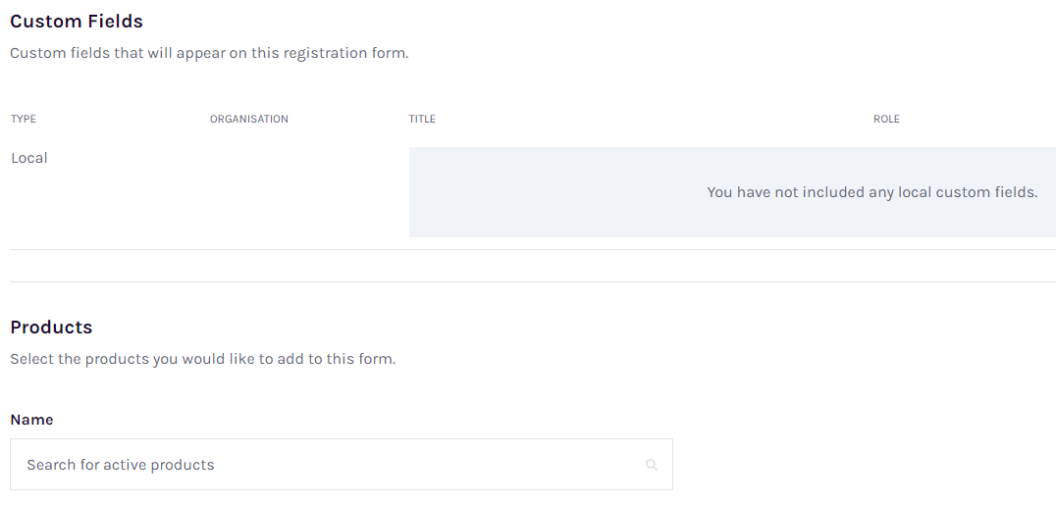
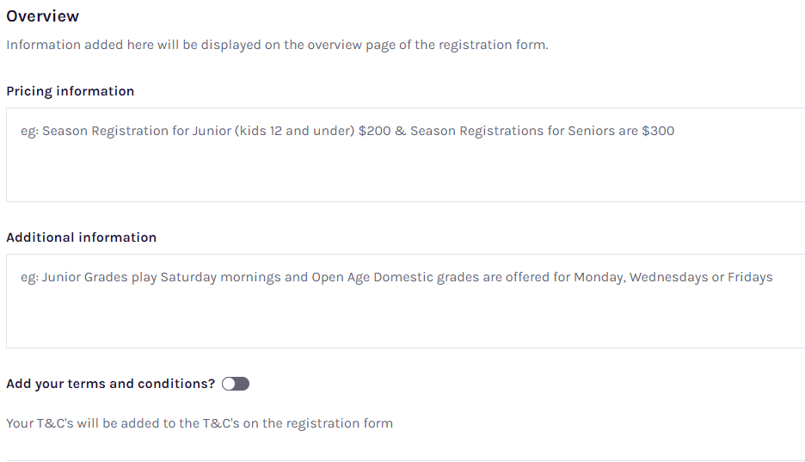
- Change the Registration visibility to Visible
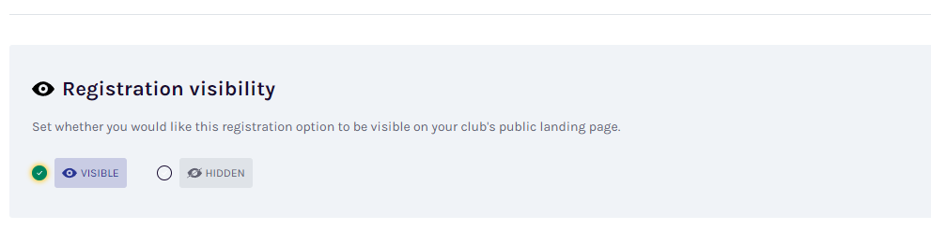
- Once complete select Save at top right of the page.
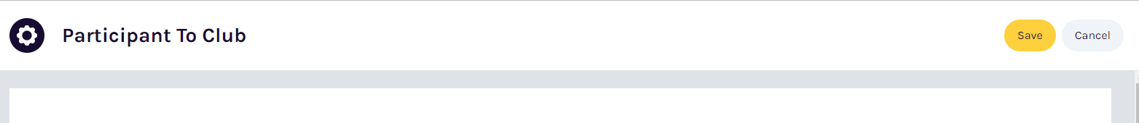
- Once saved you can then view the Registration link as per below.
This link can then be copied and inserted into a communication to the players.
